CHAPTER-1 INTRODUCTION

Need Of The Website

    - The website on e-commerce is needed in that it will make the buying of plants easy and convenient. One can shop while at home, with numerous types of plants to choose from and in-depth information about the care of the plant.
    - The website can offer professional tips, subscription options for regular plant deliveries, and customizable orders with options such as eco-friendly choices. All in all, this will make it easier for them to search for and buy plants; that is, more accessible and efficient for the lovers of plants.

Detailed Problem Definition
    - Many local stores in towns or cities can barely sell a certain range of plants, often excluding rare or exotic species that customers might be interested in. This makes it infuriating for any sort of plant enthusiast who wants to look for specific species or any different kinds of plants.
    - Shopping for plants in physical stores is a big waste of time. In addition, he must travel to various shops to get the plants of their choice, manage according to shop timings, and handle the traveling hassle. A user friendly front-end for the user to interact with the system.

    - Plant delivery includes several other issues concerning the perfect packaging, maintenance of shipping conditions, and scheduled delivery. All these issues may further cause damage to the plants and make delays in deliveries, lowering customer satisfaction.

Viability Of The System
    - First and foremost, it is market demand. People are becoming increasingly interested in plants for fashion trends in interior design, sustainable living, and individual health. This market demand needs to be understood; you would like to make certain that there is huge and continuous interest in buying plants and related products online.
    - Here, there may be established players in the e-commerce plant market, so it is required of you to research the existing competition. Scrutinize the rival's strengths and weaknesses for opportunities where you can delineate your website.

Presently Available Website
    - https://www.santhionlineplants.com
    - The site offers a diverse selection of plants, including indoor plants, outdoor plants, flowering plants, and succulents.

Future prospects
    - Growing consumer preference for convenient online plant shopping.
    - Enhanced Website.
    - Personalized shopping experiences and advanced customer support tools.

CHAPTER-2 ANALYSIS

Requirement Analysis User Roles
- Admin - Manage products (add, edit, delete). View, process, and update orders. Manage user accounts (view, delete). View analytics and sales reports.
- Customer - Browse product categories. View product details and reviews. Add products to the shopping cart. Purchase products using different payment methods. Leave product reviews.

Product Management
- Product Information - Product name, description, price, size. Stock availability. Care instructions (water, sunlight, fertilizer requirements). Customer ratings and reviews.

Order Management
- For Customers - Add/remove products from the cart. Checkout process (address, payment, review order).
- For Admin - View all orders (pending, completed, shipped). Update order statuses (pending, processing, shipped, delivered).

Payment System
  - Secure payment integration (e.g., PayPal, cash on delivery). Apply discount codes, coupons, or offers. Support for multiple currencies (optional, if international shipping is provided).

Reviews and rating
- Customers can leave reviews and star ratings on products they purchase. Reviews should be displayed on the product detail page. Admin should be able to moderate reviews (approve/delete inappropriate reviews).

Customer Support
- FAQ section for common questions regarding plants and gardening care. Return/refund policies.

User Account Management
- User registration and login (email/password, social media login). Profile management (update name, email, password, delivery addresses).

Project Model

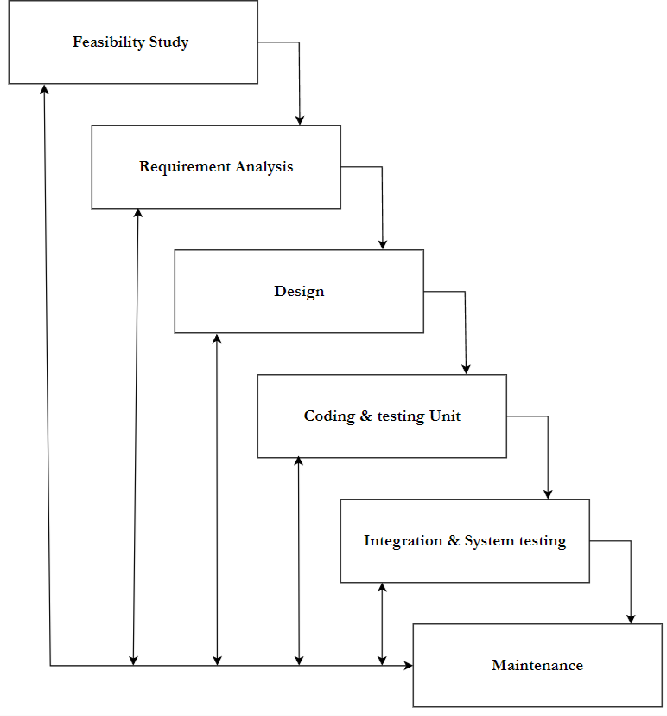

[Figure 1: Iterative Waterfall Model]

- This application is developed using Iterative model. Almost every other model is derived from the waterfall model.
- The phase of detecting errors is close to its points of introduction is known as face containment of errors.

- Incremental model is also referred as the successive version of waterfall model using incremental approach and evolutionary model.
- In this model, the system has broken down into several modules which can be incrementally implemented and delivered.
- First develop the core model and when customer evaluate the system then the initial product skeleton is redefined into increasing levels capacity by adding new functionalities in successive versions.

Advantages
- Each successive version performing more useful work than previous versions.
- The core modules get tested thoroughly, thereby reducing change of error in final product.
- The model is more flexible and less costly to change the scope and requirement.
- User gets a change to experiment with partially developed software.
- This model helps finishing exact user requirements.
- Feedback providing at each increment is useful for determining the better final product.

Schedule Representation
Generalized project scheduling tools and technique can be applied with little modification to software projects.

Project evolution and review technique and critical paths method are two project scheduling method that can be applied to software development. Both techniques are driven by information already developed in earlier project planning activities:
- A decomposition of the product function.
- The selection of appropriate process model and task set.
- Estimate of effort.
- Decomposition

[Table 1: Schedule Representation]

ACTIVITY | START DATE | FINISH DATE
Requirement
Analysis
System Analysis
System Design
System Coding
Testing and
Integration

Feasibility Study

Technical Feasibility

      - The proposed system will be developed in web bases completely and it is required to use web technologies appropriately. Technology to build the overall system is available.
      - Currently Available web technology - HTML, CSS, JavaScript (front-end) and Python (Django/Flask), Node.js (back-end).

      - Servers – pyhtonanywhere
      - DBMS – MySql

Economical Feasibility

      - Economic feasibility is the most frequently used method for evaluating the effectiveness of a new system. More commonly known as cost/benefit analysis, the procedure is to determine the benefits and savings that are expected from a candidate system and 8 compare them with costs. If benefits outweigh costs, then the decision is made to design and implement the system.

Operational Feasibility

      - Definition: Operational feasibility assesses how effectively a proposed system addresses the identified problems and leverages opportunities from the scope definition and problem analysis phases, and how well it satisfies the system requirements from the requirement analysis phase.
      - User Familiarity: The potential users of the Plants and Greenery e-commerce website will be familiar with basic web navigation and interaction, making the training process straightforward and efficient. Basic training on managing products, processing orders, and using admin functionalities will be sufficient for most users.
      - Data Security: The system will include robust security features by implementing multiple access levels for various users (e.g., admin,

vendor, customer). Secure authentication, authorization, and auditing procedures will be in place to safeguard sensitive data and provide system administrators with full control over the site’s operations.
      - Data Management: Data retrieval for products, customer details, and orders will be efficient. Advanced querying mechanisms, search filters, and backend database management systems (such as MySQL or SQLite) will ensure quick and smooth data access.

CHAPTER-3
DESIGN

Data Flow Diagram
    - DFD (data flow diagram) is also known as bubble chart or data flow graph.
    - DFD’s are very useful in understanding the system and can be effectively used during analysis. It shows flow of data through a system visually. The DFD is a hierarchical graphical model of a system the different processing activities or functions that the system performs and the data interchange among these functions.
    - It views a system as a function that transforms the inputs into desired output.
    - Each function is considered as a process that consumes some input data and produces some output data.
    - Function model can be represented using DFD.
    - DFD graphically representing the functions, or processes, which capture, manipulate, store, and distribute data between a system and its environment and between components of a system.
    - The visual representation makes it a good communication tool between User and System designer.
    - Structure of DFD allows starting from a broad overview and expand it to a hierarchy of detailed diagrams.
    - DFD has often been used due to the following reasons:
      - Logical information flow of the system.
      - Determination of physical system construction requirements.

      - Simplicity of notation.
      - Establishment of manual and automated systems requirements.

[Table 2: Data Flow Diagram Symbols]

Symbols | Description
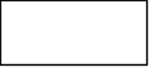 | Entity: Entities are external to the system which interacts by inputting the data.
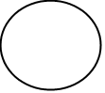 | System: It shows the system name.
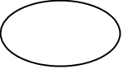 | Process: It shows the part of the system that transforms into outputs.
 | Data Flow: It passes the data from one part to another.
 | Data Store: Data store is represented by two parallel lines. It is generally logical file or database.

Level 0: Context
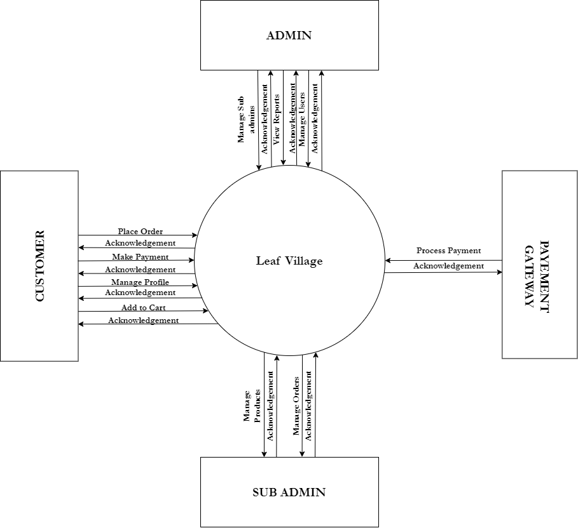

[Figure 2: Context level]

Level 1: Admin
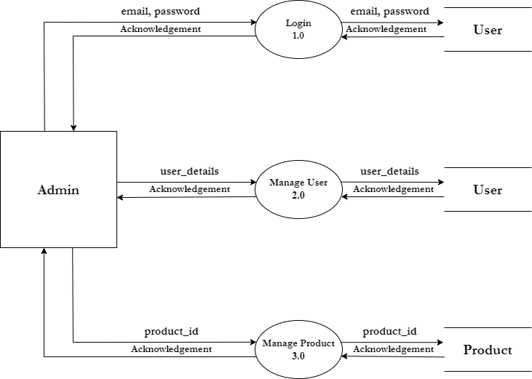

[Figure 3: DFD Level 1: Admin]

Level 1: Customer
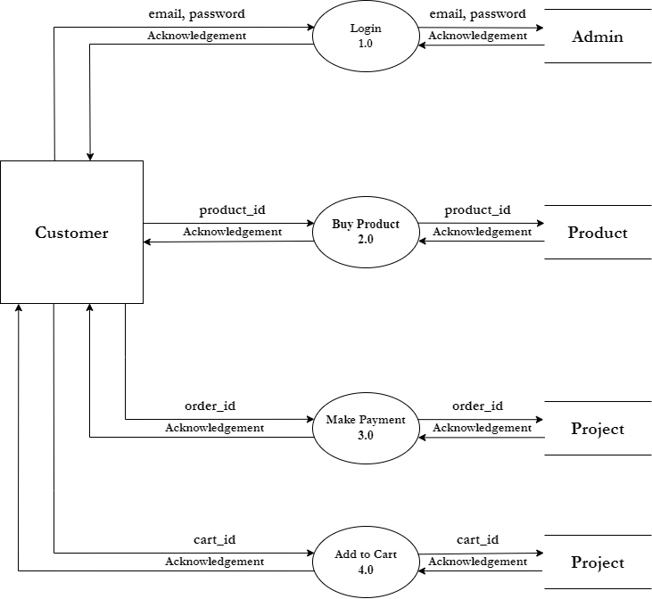

[Figure 4: DFD Level 1: Customer]

Level 1: Payment Gateway
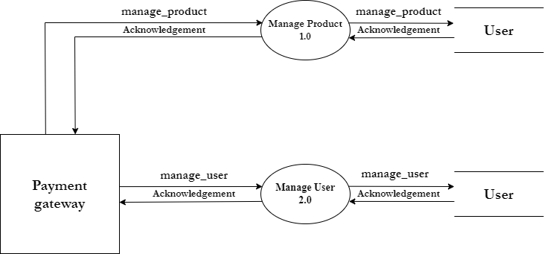

[Figure 5: DFD Level 1: Payment Gateway]

Level 1: Sub Admin
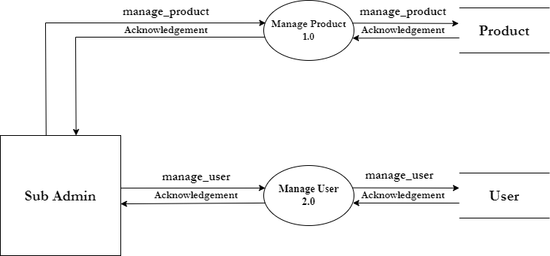

[Figure 6: DFD Level 1: Sub Admin]

ER-Diagram

An Entity Relationship (ER) Diagram is a type of flowchart that illustrates how “entities” such as people, objects or concepts relate to each other within a system. ER Diagrams are most often used to design or debug relational databases in the fields of software engineering, business information systems, education and research. Also known as ERDs or ER Models, they use a defined set of symbols such as rectangles, diamonds, ovals and connecting lines to depict the interconnectedness of entities, relationships and their attributes. They mirror grammatical structure, with entities as nouns and relationships as verbs.

[Table 3: ER-Diagram Symbols]

Symbols | Description
 | Entity: Data object is real world entity or  thing. It is represented by a rectangle shape. An entity is an object or concept about which you want to store information.
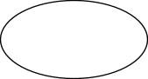 | Attributes: An attribute is property of characteristic of an entity. It is represented by oval shape.
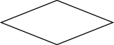 | Relationship: Entity are connected each other via relations. Generally, relationships in binary because there are two entities are related to each other.
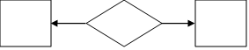 | Cardinality (One to One): An instance of entity A can relate to one instances of entity B.
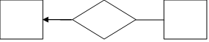 | Cardinality (One to Many): An instance of entity A can relate to one or many instances of B but we can only relate one instance of A.
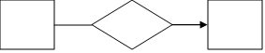 | Cardinality (Many to One): One or more instances of entity A can relate to one instances of B.
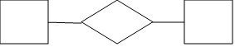 | Cardinality (Many to Many): One or more instances of entity A can relate to one more instance of entity B.

ER-Diagram:
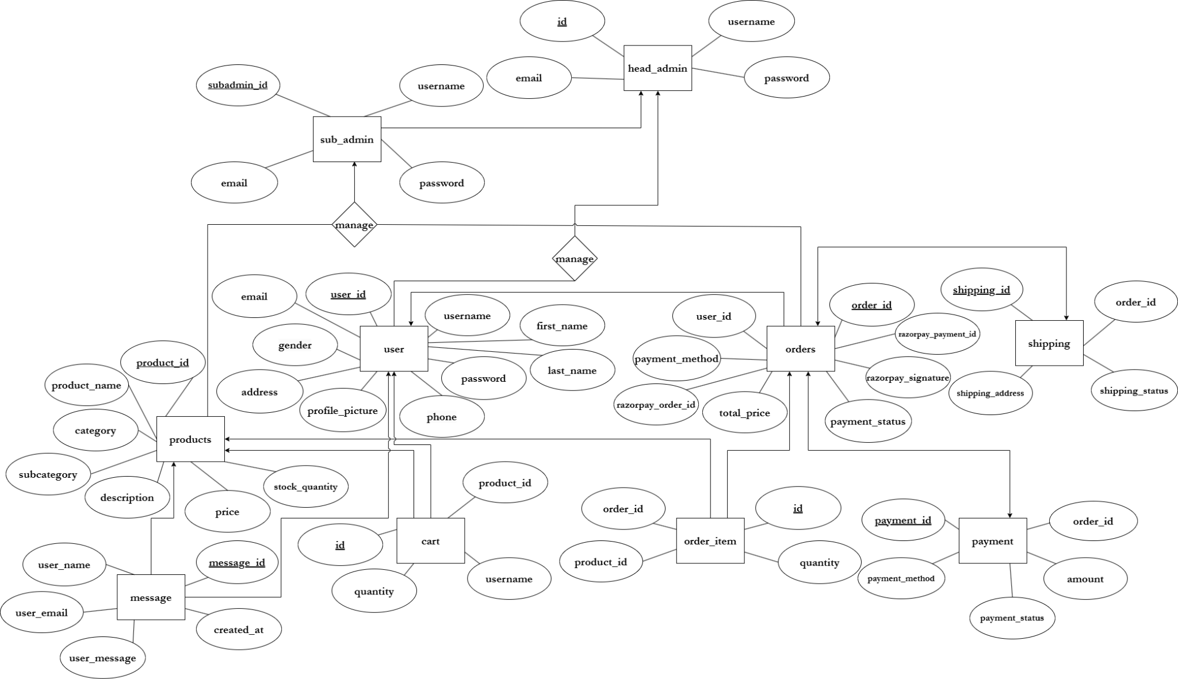

[Figure 7: ER Diagram]

CHAPTER-4 SYSTEM MODELING

Database Dictionary
    - Table Name: head_admin

Primary Key: head_admin_id
[Table 4: head_admin]

SR  NO. | FIELDNAME | DATATYPE  (SIZE) | CONSTRAINT | DESCRIPTION
1 | head_admin_id | INT(5) | Primary Key | Unique identifier  for each admin.
2 | username | VARCHAR (255) | Unique Key | Username of the user.
3 | email | VARCHAR  (255) | Unique Key | Email address.
4 | password | VARCHAR  (255) | Unique Key | Password for  securtiy.

    - Table Name: products

Primary Key: product_id

[Table 5: products]

SR.  NO | FIELDNAME | DATATYPE  (SIZE) | CONSTRAINT | DESCRIPTION
1 | product_id | INT(3) | Primary Key | Unique identifier for each product.
2 | category | VARCHAR (255) | Not Null | Category of the product.
3 | subcategory | VARCHAR  (255) | Not Null | Subcategory of  the product.
4 | image_url | TEXT | Not Null | URL of the product image.
5 | steps_to_grow | TEXT | Not Null | Guide on how to grow the plant.
6 | product_name | VARCHAR (255) | Not Null | Name of the  product.
7 | description | TEXT(255) | Not Null | Detailed description of the product.
8 | price | DECIMAL (10,2) | Not Null | Price of the product
9 | stock_quantity | INT(3) | Not Null | Quantity  available in stock.

    - Table Name: orders Primary key: order_id Foreign Key: user_id
[Table 6: orders]

SR.  NO | FIELDNAME | DATATYPE  (SIZE) | CONSTRAINT | DESCRIPTION
1 | order_id | INT(10) | Primary Key | Unique identifier  for each order.
2 | user_id | INT(5) | Foreign Key | User who placed  the order.
3 | shipping_address | TEXT | Not Null | Shipping address  for the order.
4 | razorpay_order_id | VARCHAR (255) | Not Null | Razorpay order  ID.
5 | razorpay_payment  _id | VARCHAR (255) | Not Null | Razorpay  payment ID.
6 | razorpay_signatur e | VARCHAR (255) | Not Null | Razorpay signature for  validation.
7 | order_date | DATE/ TIME | DEFAULT CURRENT_TI  MESTAMP | Timestamp when the order was  placed.
8 | total_price | DECIMAL( 10,2) | Not Null | Total price of the order.
9 | shipping_price | TEXT(255) | Not Null | Shipping address for this specific  order.
10 | order_status | ENUM(‘Pe  nding’,  ‘Shipped’, ‘Delivered’, ‘Cancelled’) | Not Null | Status of the order.
11 | Payment_method | ENUM(‘Pe  nding’,  ‘Completed’, ‘Failed’) | Not Null | Payment status of  the order.

    - Table Name: order_items

Primary Key: id
Foreign Key: order_id, product_id
[Table 7: order_items]

SR.  NO | FIELDNAME | DATATYPE  (SIZE) | CONSTRAINT | DESCRIPTION
1 | id | INT(10) | Primary Key | Unique identifier for each order  item.
2 | order_id | INT(10) | Foreign Key | Order to which  the item belongs.
3 | product_id | INT(5) | Foreign Key | Product being ordered.
4 | quantity | INT(3) | Not Null | Quantity of the  product ordered.

    - Table Name: shopping_cart
Primary Key: cart_id
Foreign Key: user_id, product_id
[Table 8: shopping_cart]

SR.  NO | FIELDNAME | DATATYPE(  SIZE) | CONSTRAINT | DESCRIPTION
1 | cart_id | INT(3) | Primary Key | Unique identifier for  each cart item.
2 | user_id | INT(5) | Foreign Key | User who owns  the cart.
3 | product_id | INT(3) | Foreign Key | Product added to the cart.
4 | quantity | INT(5) | Not Null | Quantity of the product added to  the cart.

    - Table Name: payment Primary Key: payment_id Foreign key: order_id
[Table 9: payment]

SR.  NO | FIELDNAME | DATATYPE(  SIZE) | CONSTRAINT | DESCRIPTION
1 | payment_id | INT(10) | Primary Key | Unique identifier  for each payment.
2 | order_id | INT(10) | Foreign Key | Order for which the  payment was made.
3 | amount | DECIMAL (10,2) | Not Null | Total amount paid.
4 | payment_method | ENUM(‘Pay  Pal’, ‘Cash on Delivery’) | Not Null | Method used for the payment.
5 | Payment_status | ENUM(‘Pen  ding’,  ‘Completed’, ‘Failed’) | Not Null | Status of the payment.

    - Table Name: messages

Primary key: message_id

[Table 10: messages]

SR.  NO | FIELDNAME | DATATYPE  (SIZE) | CONSTRAINT | DESCRIPTION
1 | message_id | INT(10) | Primary Key | Unique identifier  for each review.
2 | user_name | VARCHAR (255) | Not Null | Name of the user sending the  message.
3 | user_email | VARCHAR  (255) | Not Null | Email of the user  sending the message.
4 | user_message | TEXT(255) | Not Null | Message content  sent by the user.
5 | created_at | TIME  STAMP | DEFAULT  CURRENT_TI MESTAMP | Timestamp when  the message was created.

    - Table Name: shipping Primary Key: shipping_id Foreign Key: order_id
[Table 11: shipping]

SR.  NO | FIELDNAME | DATATYPE  (SIZE) | CONSTRAINT | DESCRIPTION
1 | shipping_id | INT(10) | Primary Key | Unique identifier for each shipping record.
2 | order_id | INT(5) | Foreign Key | Order associated  with the shipping.
3 | shipping_addres s | TEXT(255) | Not Null | Address to which the order is shipped.
4 | shipping_status | ENUM(‘Pen  ding’, ‘In Transit’, ‘Delivered’) | Not Null | Shipped status.

    - Table Name: user
Primary Key: user_id

[Table 12: user]

SR. NO | FIELDNAME | DATATYPE (SIZE) | CONSTRAINT | DESCRIPTION
1 | user_id | INT(5) | Primary Key | Unique identifier for each user.
2 | username | VARCHAR (225) | Not Null | Full name of the user.
3 | email | VARCHAR (255) | Unique Key | Email address.
4 | password | VARCHAR  (255) | Not Null | Hashed  password for security.
5 | phone | VARCHAR (12) | Unique Key | Contact number of the user.
6 | address | TEXT(255) | Not Null | Shipping address for deliveries.
7 | role | VARCHAR (255) | DEFAULT 'user' | Role of the user (default is 'user').
8 | first_name | VARCHAR (255) | Not Null | First name of the user.
9 | last_name | VARCHAR  (255) | Not Null | Last name of the  user.
10 | gender | ENUM('mal e','female') | Not Null | Gender of the user.
11 | profile_picture | VARCHAR (255) | Not Null | User’s Profile.

    - Table Name: subadmins
Primary Key: subadmin_id
[Table 13: subadmins]

SR  NO. | FIELDNAME | DATATYPE(  SIZE) | CONSTRAINT | DESCRIPTION
1 | subadmin_id | INT(5) | Primary Key | Unique identifier for each sub  admin.
2 | username | VARCHAR  (255) | Unique Key | Username of the  user.
3 | email | VARCHAR( 255) | Unique Key | Email address.
4 | password | VARCHAR  (255) | Unique Key | Password for  securtiy.

CHAPTER-5 TECHNICAL SPECIFICATION

Hardware Specification:
    - 5.1.1 Ram: 4GB
    - 5.1.2 Hard Drive Storage Needed: 20GB
    - 5.1.3 Other Hardware Requirement: None

Platform:
    - 5.2.1 Supported Operating System: Windows 10 or above LINUX and MacOS is also compatible.
    - 5.2.2 Programmer Server: PythonAnywhere

Framework
    - 5.3.1 Mark-up Language: HTML4 and HTML5
    - 5.3.2 Programming Language: Python 3.12.4

Technical Specification:
    - 5.4.1 Front-End: JavaScript ES6
    - 5.4.2 Back-End: MySQL 8.0
    - 5.4.3 IDE Tools: VS Code
    - 5.4.4 UML Tools: draw.io
    - 5.4.5 SRS Tools: Microsoft Word 2016.

DESIGN LAYOUT
Homepage:-


[Figure 8: Home Page]

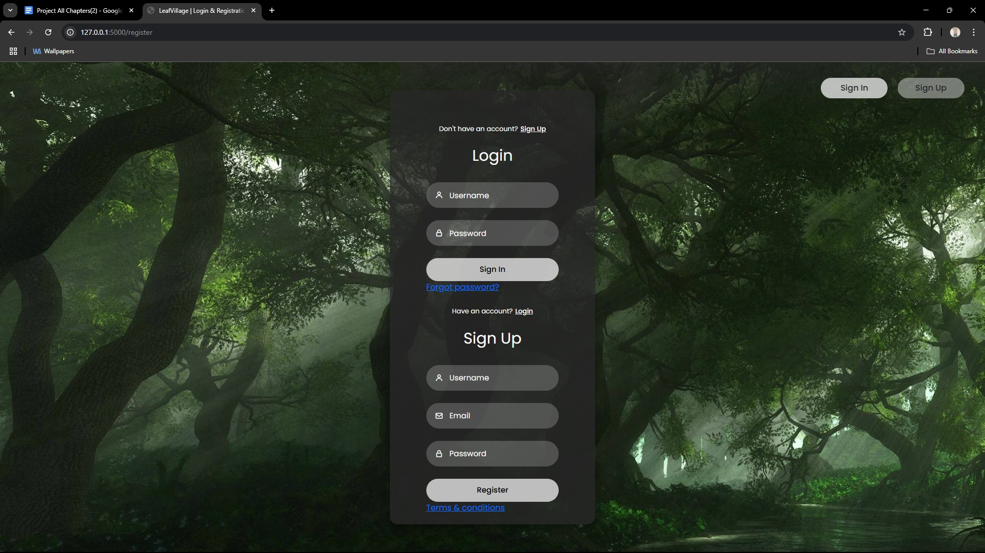

[Figure 9: User Login/Sign Up Page]

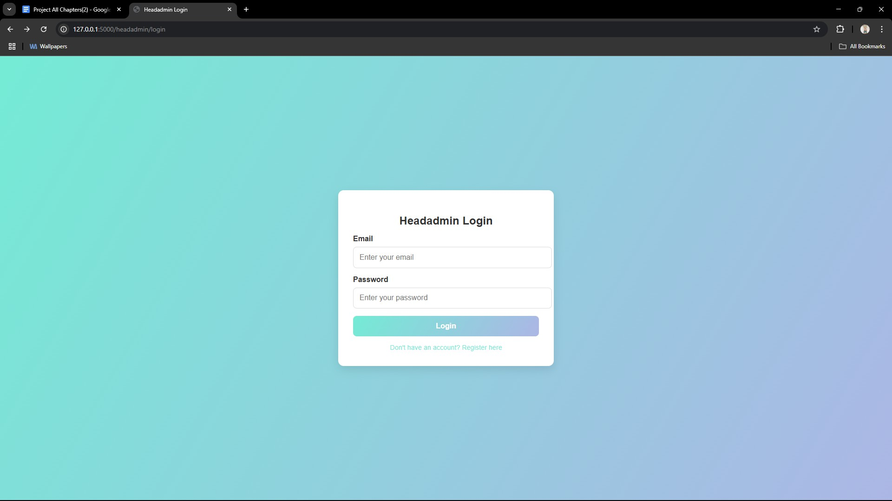

[Figure 10: Admin Login Page]

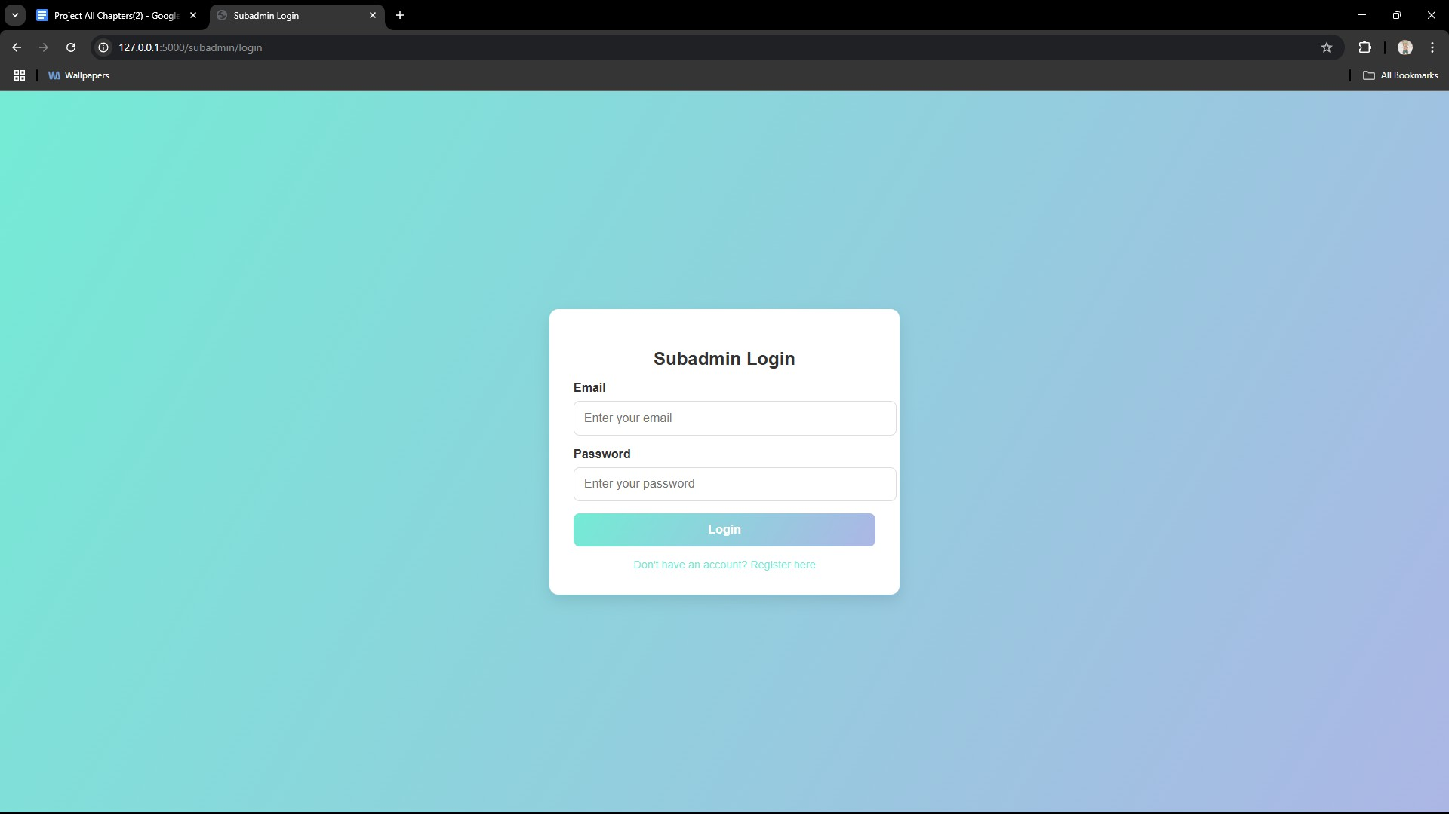

[Figure 11: Subadmin Login Page]
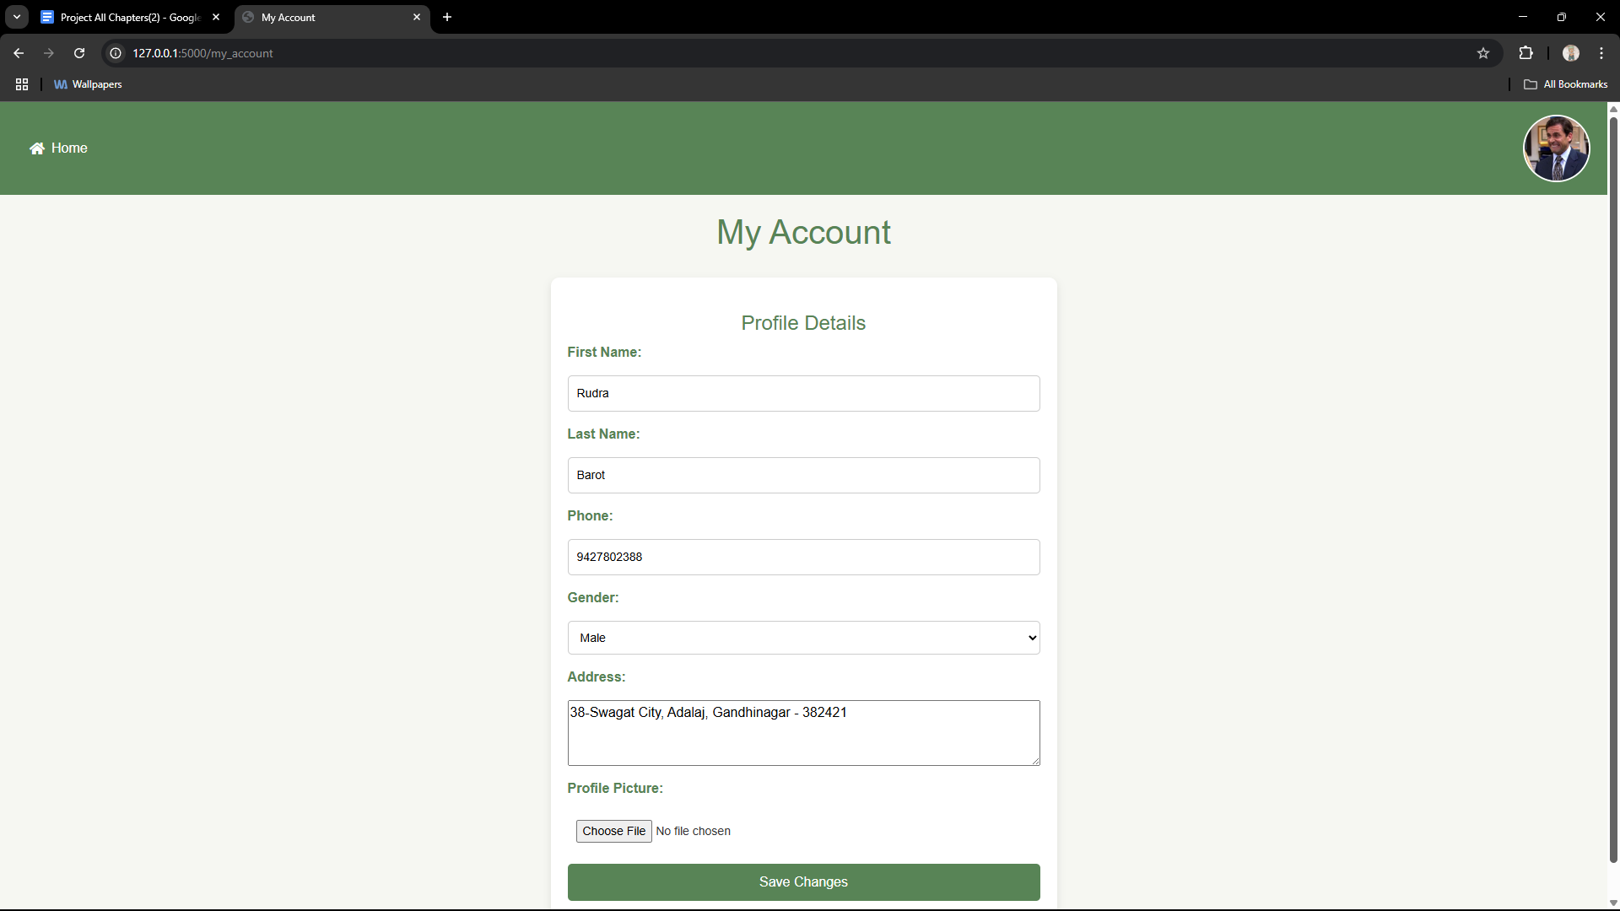

[Figure 12: User Account Management Page]

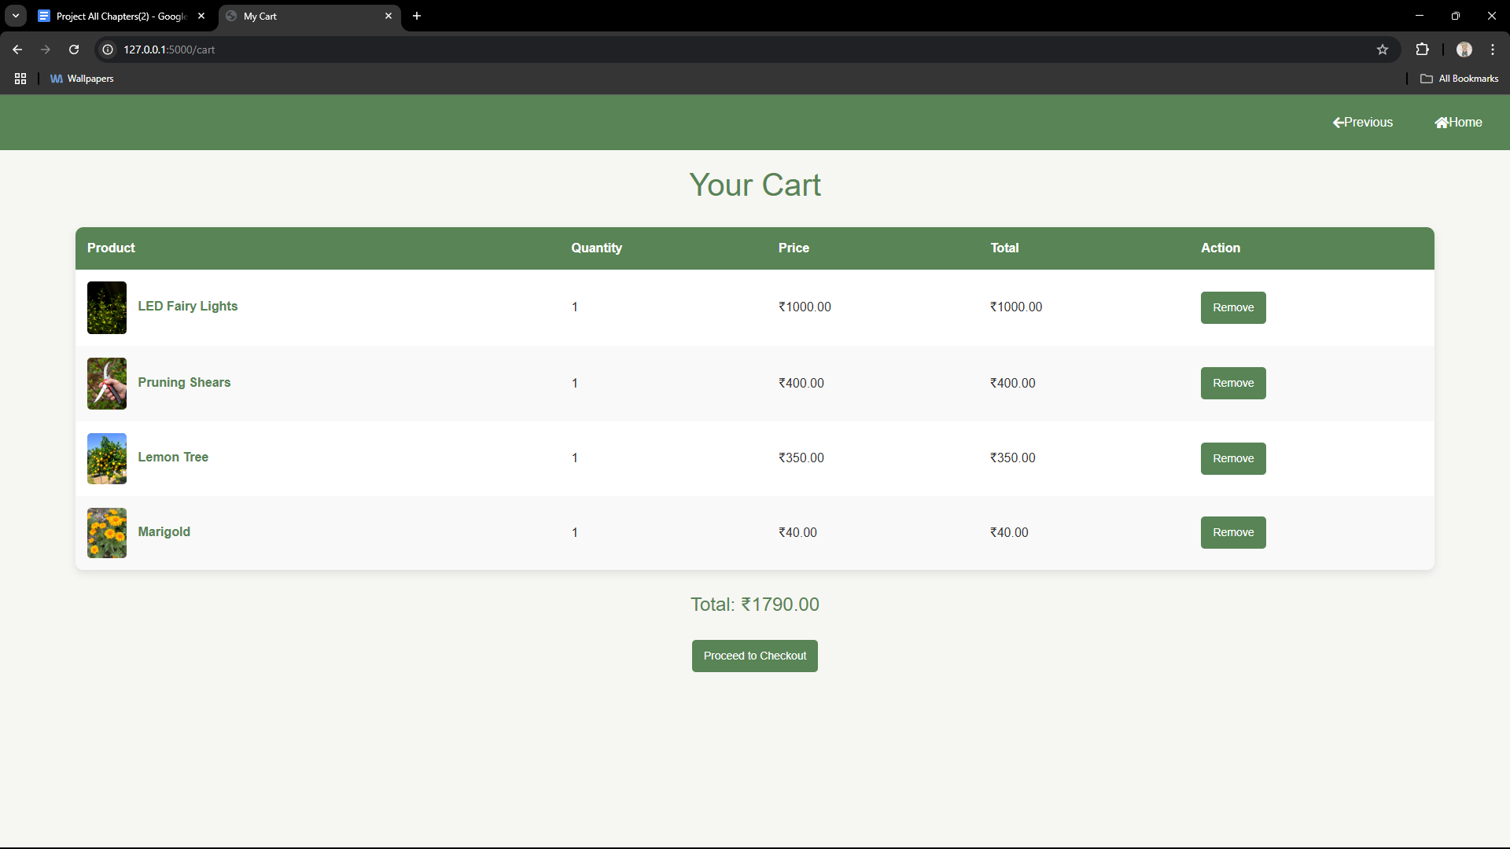

[Figure 13: User’s Cart]

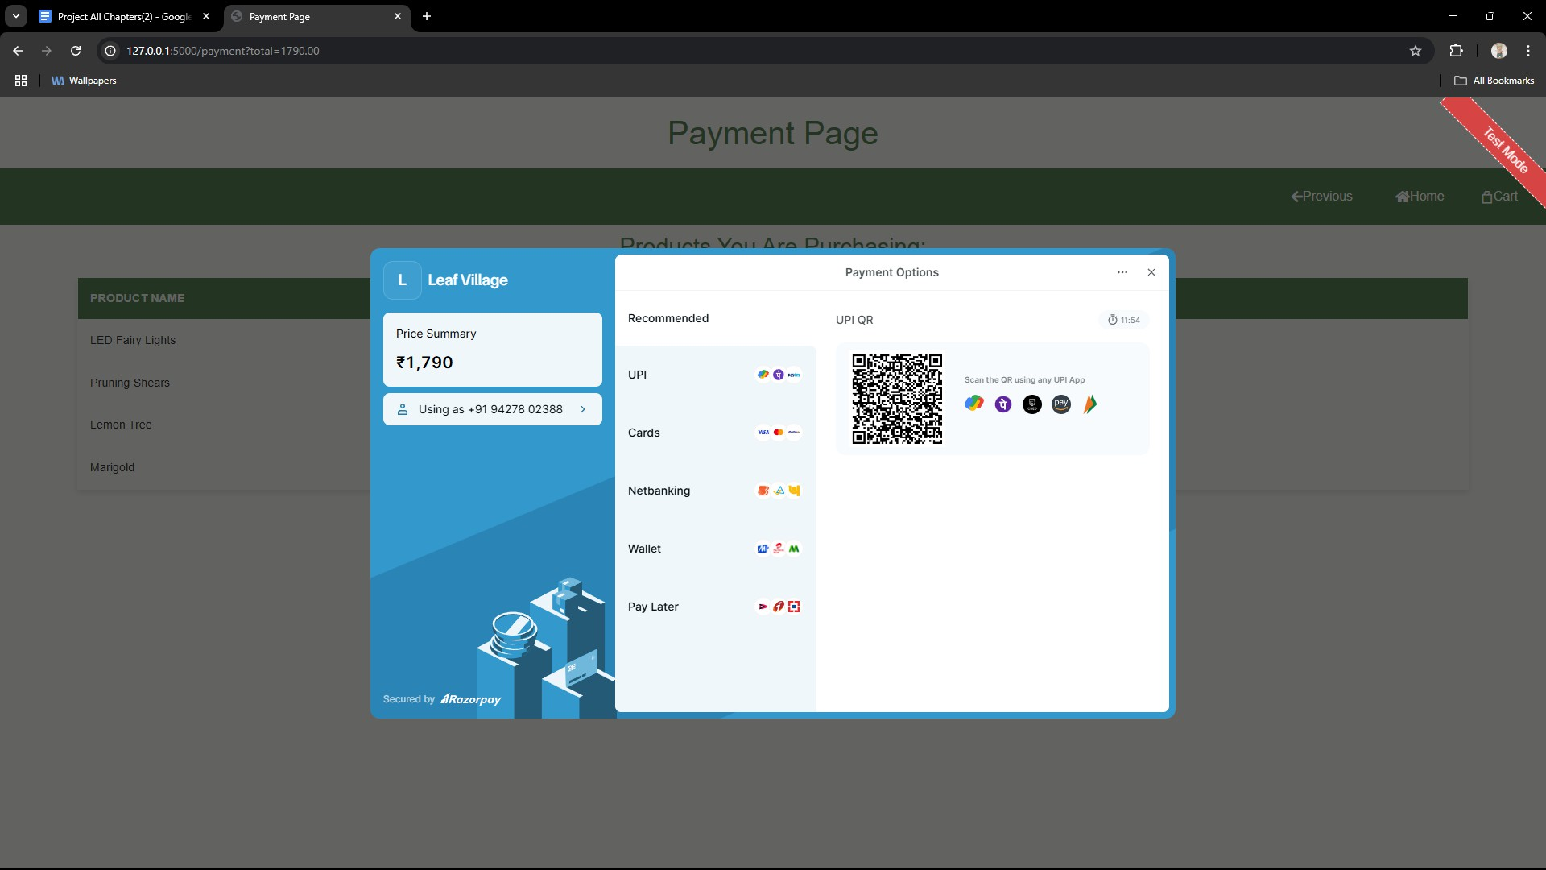

[Figure 14: Payment Page]

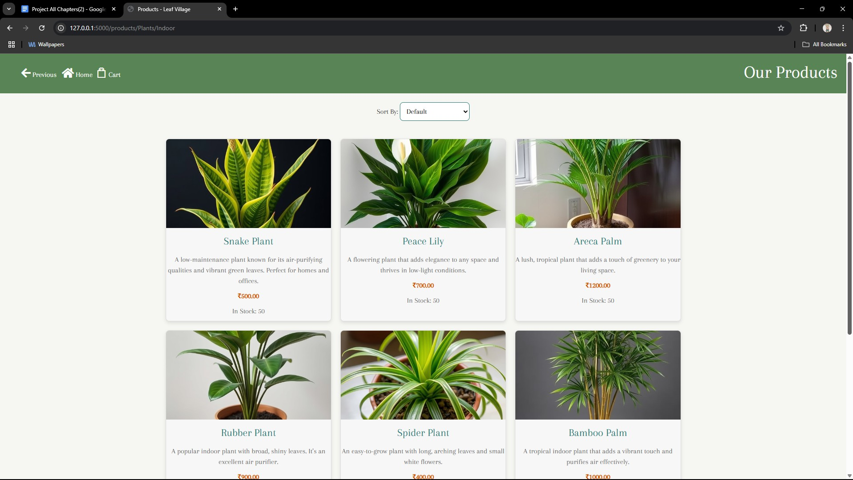

[Figure 15: Products Page]

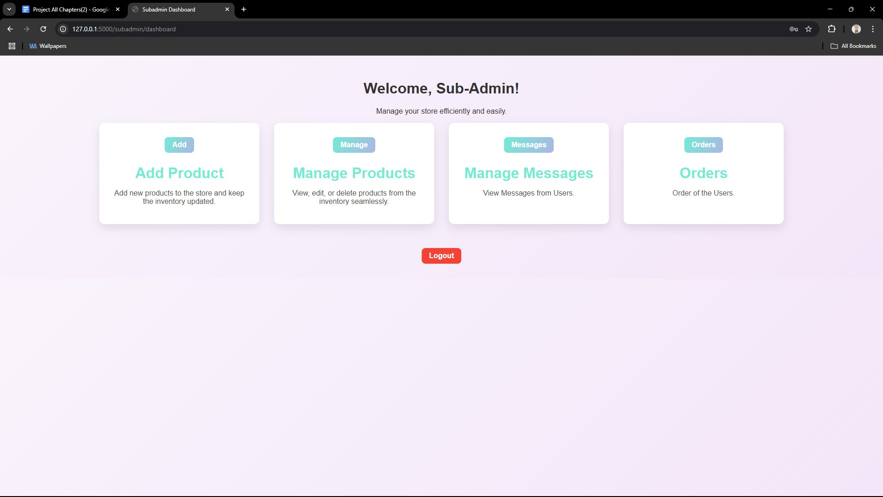

[Figure 16: Subadmin Dashboard Page]

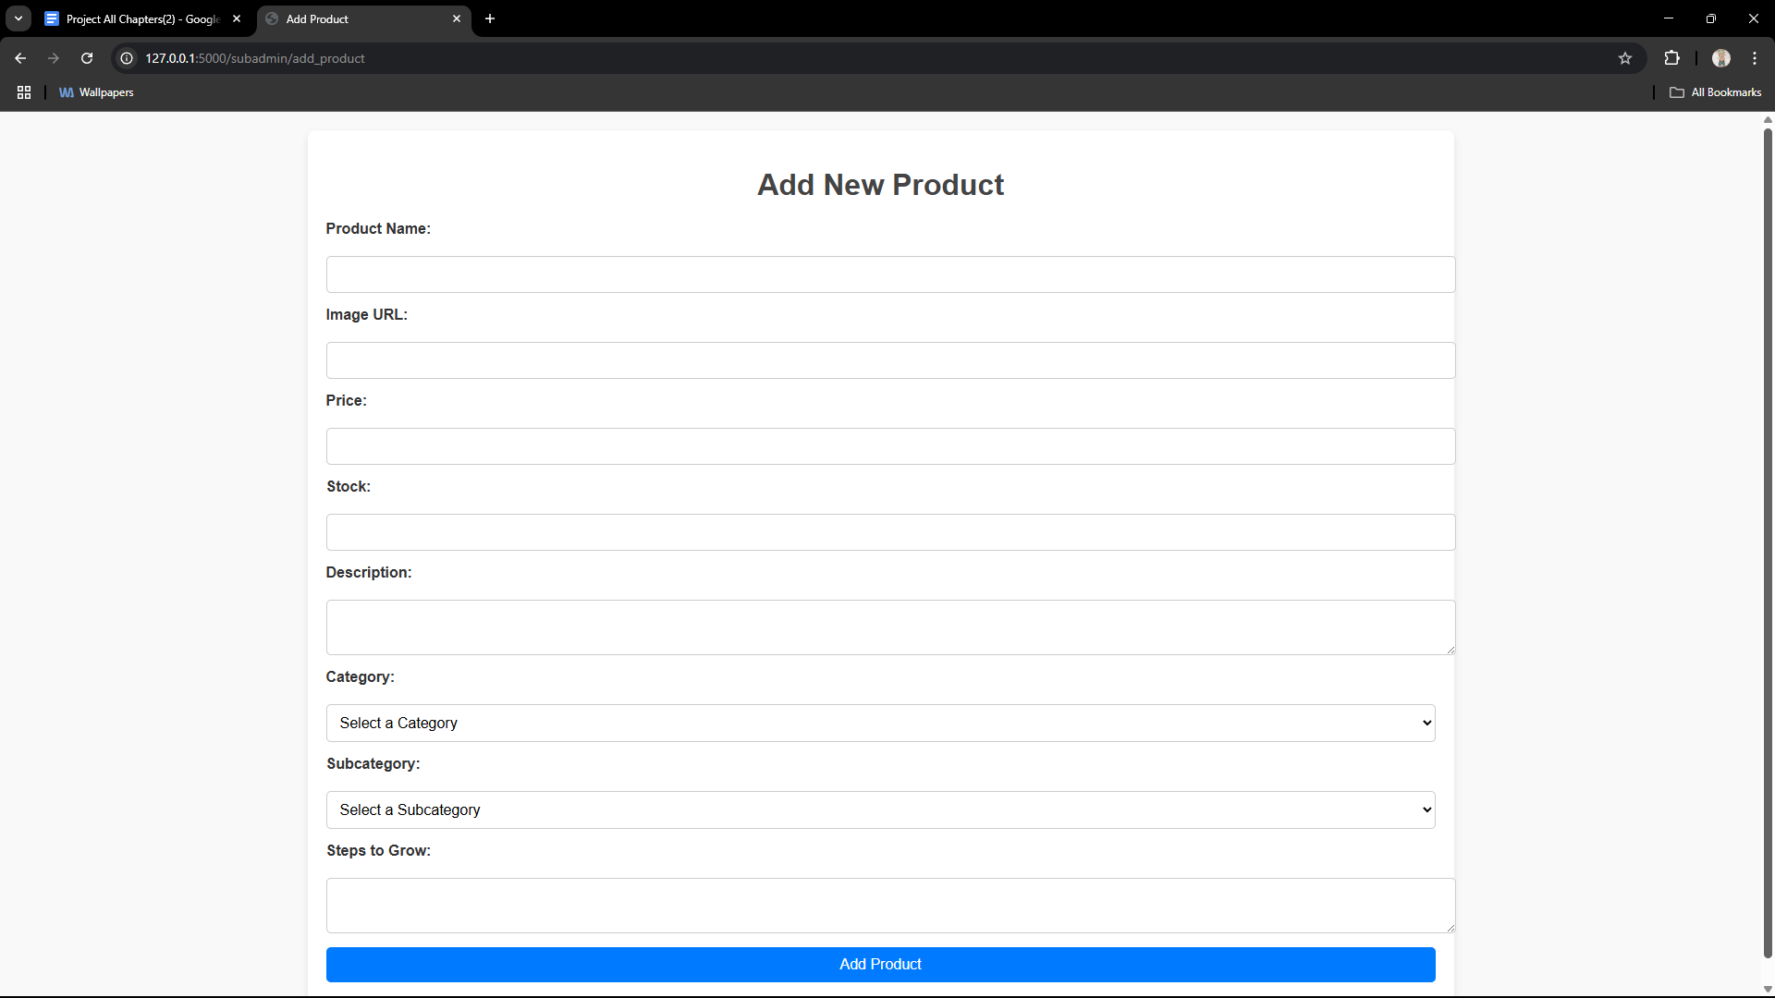

[Figure 17: Add Products Page]

CHAPTER-6 TESTING
  - Overview

Testing is a critical component in the software development lifecycle, aimed at identifying and resolving errors to ensure that the system meets its in- tended requirements. For the Leaf Village, testing was performed to verify functional accuracy, performance, and overall reliability.
This chapter covers the testing methodologies, techniques used, test cases designed, and results obtained during the testing phase.

Testing Methods
The testing process incorporated two widely used methodologies:

Black-box Testing
Black-box testing focuses on verifying that the system operates as intended without examining its internal structures or logic. This type of testing en- sures:
      - Proper handling of user inputs.
      - Accurate generation of expected outputs.
      - Integrity of data stored and retrieved from the database.
      - Smooth interaction between different modules.

White-box Testing
White-box testing examines the internal workings of the system. It evaluates the implementation logic and ensures:
      - All paths within the system are executed at least once.
      - Logical conditions are verified for both true and false outcomes.
      - Loops are tested to ensure they function correctly under defined boundaries and conditions.

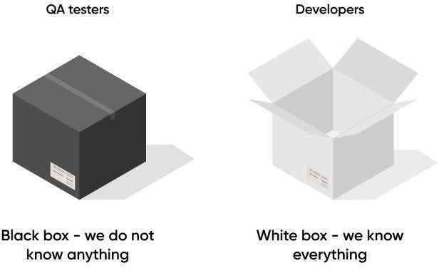

[Figure 19: Testing]

Testing Techniques Used
To ensure the app worked as expected, we applied the following testing tech- niques:
- Unit Testing – We tested individual components like login, signup, payment processing, and product upload to ensure they functioned correctly on their own.
- Integration Testing – We verified that different modules (like Hash Password, payment processing, and image storage) worked smoothly together.
- UI Testing – We manually checked buttons, navigation, and layouts to con- firm a good user experience across different web pages.
- Performance Testing – We observed website load times and tested how it han- dled multiple requests simultaneously.
- Error Handling Testing – We intentionally caused failures (e.g., network disconnection during payment or product upload) to check if the app displayed proper error messages.
- Real Device Testing – We ran the website on a physical windows device to

check real-world usability.

Tools Used:
  - Visual Studio Code (VS Code) – Code editor for writing and managing the website's code.
  - Flask – Web framework for building the website.
  - MySQL – Database for storing product details and user information.
  - Razorpay – Payment gateway integration for secure transactions.
  - HTML, CSS, JavaScript– For front-end development.

Test Cases and Execution
Detailed test cases were designed to cover all aspects of the system’s func- tionality. Below are examples of test cases:

Test Case 1: User Signup
- Description: Verify that a new user can successfully sign up.
- Input: Unique email, username, and password.
- Expected Output: Account created successfully.
- Actual Output: Account created successfully.
- Status: ⬛ Passed

Test Case 2: User Login
- Description: Verify that a registered user can log in.
- Input: Correct email and password.
- Expected Output: User is logged in and redirected to the dash- board.
- Actual Output: User is logged in and redirected to the dashboard.
- Status: ⬛ Passed

Test Case 3: Payment
- Description: Verify that a payment is processed successfully.

- Input: Valid payment details through Razorpay.
- Expected Output: Payment is processed, and details are stored.
- Actual Output: Payment is processed, and details are stored.
- Status: ⬛ Passed

Test Case 4: Adding product
- Description: Verify that subadmin can add new product with no error.
- Input: product details like name, price, image etc
- Expected Output: Product is added successfully in database
- Actual Output: Product is added successfully in database
- Status:⬛ Passed

Test Case 5: Edit Product
- Description: Verifying that the subadmin can edit the details of the product
- Input: Edited product details
- Expected Output: The edited data of the product is overwritten in the place of existing data
- Actual Output: The edited data of the product is overwritten in the place of existing data
- Status:⬛ Passed

Results and Observations
The testing process revealed the following outcomes:
- Account Management: New user can register or the old user can login with their credentials and the account details can be edited
- Payment Processing: Product purchase payments is handled through the Razorpay payment gateway without any major issues user can pay for it via various methods
- Product Management: Sub-Admin can Add new products or edit the existing ones seamlessly via their dashboard
- Admin Supervision: The Head-Admin (Super-Admin) can overview the activities going on in the website via the dashboard provided the user and Sub-Admin logins and order tracking are possible
- Minor inconsistencies in UI elements may occur and data loading and
storing may take some time based on connectivity strength of the user
.

Challenges Encountered
During the testing process, the following challenges were faced:

- Storing Order history: We face an issue of retrieving the order history from the Razorpay dashboard after the purchase was a success as the API was a new ground for use
- UI inconsistencies: As our web was not as responsive as it should have been we faced a challenge to set the elements of the website properly on different device and screen size with various adjustments
- Latency: As the data query is sent to the database executed and then the output is give some tasks took longer than expected to respond to the user input

CONCLUSION
It was a great experience to design and implement the Leaf-Village (Plants and Greenery website) by using Python and to work on its documentation. While working on this project we have learned many things especially how to apply the concept of Python in modelling of real world systems. This project is developed using Python, HTML, CSS, JavaScript and MySQL fully meets the objective of the system which it has been developed. This project is used for easy buying of plants and its tools to maintain and grow various types of herbs. The website allows you to buy plants, tools etc. The website also provides you with a small manual of how to grow and maintain plants, which separates this website from the others.

BIBLIOGRAPHY

Book Reference
- Python crash course, Second Edition Author: Eric Matthes Published by: No Starch Press in 2019.
- Javascript: The Definitive Guide, Seventh Edition Author: David Flanagan Published by: O’Reilly Media in 2020.
- MySQL Cookbook: Solutions for Database Developers and Administrators, Fourth Edition Author: Paul DuBois Published by: O'Reilly Media in 2014.

Web Reference
- W3schools
Link: https://www.w3schools.com/django/django_admin.php

- W3schools
Link: https://www.w3schools.com/js/js_validation_api.asp

- W3schools
Link: https://www.w3schools.com/sql/sql_hosting.asp

